Logistic Population Models with Harvesting

Chapter 1: Introduction
1.1 Background
The study of population dynamics has been a fundamental concern in both ecology and applied mathematics for centuries. Understanding how populations grow, stabilize, and decline is essential for managing natural resources, particularly in fisheries where human harvesting directly influences population behavior.
The earliest formal mathematical treatment of population growth was proposed by Thomas Robert Malthus in 1798, who described population growth as purely exponential — that is, a population grows at a rate proportional to its current size. While this model captured the basic idea of biological reproduction, it failed to account for the natural limits imposed by the environment, such as limited food supply, space, and competition among individuals. In reality, no population can grow indefinitely.
To address this limitation, Pierre François Verhulst introduced the logistic growth model in 1838, which incorporated the concept of a carrying capacity — the maximum population size that an environment can sustainably support. The logistic equation produced more realistic population behavior, showing that populations grow rapidly when small, slow down as they approach the carrying capacity, and eventually stabilize. This model became the foundation for much of modern population ecology.
In the context of fishery management, the logistic model was further developed to include the effect of harvesting — the deliberate removal of individuals from the population. Two major harvesting strategies have been widely studied: constant harvesting, where a fixed number of fish are removed per unit time regardless of the population size, and periodic harvesting, which reflects the seasonal nature of real fishing activity where fishing grounds are opened and closed at regular intervals throughout the year.
These mathematical models, expressed as ordinary differential equations (ODEs), allow researchers and policymakers to analyze the long-term behavior of fish populations under different harvesting pressures, identify critical thresholds, and design sustainable harvesting strategies that prevent extinction while maximizing yield.

1.2 Problem Statement
Fish populations worldwide are under increasing pressure from commercial and subsistence fishing. According to the Food and Agriculture Organization of the United Nations, a significant portion of global fish stocks are either fully exploited or overexploited, meaning they are being harvested at or beyond their biological limits. When harvesting exceeds the natural capacity of a population to recover, the population enters a state of irreversible decline that can ultimately lead to commercial extinction or even biological extinction of the species.
The central problem addressed in this study is the determination of safe and sustainable harvesting rates for a fish population governed by logistic growth dynamics. Specifically, the study asks: at what harvesting rate does a fish population remain stable, and at what point does harvesting cause the population to collapse? Furthermore, how does the pattern of harvesting — whether constant or periodic — affect the long-term survival and stability of the population?
These questions cannot be answered by intuition or observation alone. A rigorous mathematical framework is needed to model the interaction between natural population growth and human harvesting activity, to identify equilibrium states, to assess their stability, and to determine the critical harvesting threshold known as the Maximum Sustainable Yield (MSY) — the largest harvesting rate that a population can withstand without being driven toward extinction.

1.3 Significance of the Study
This study is significant for several interconnected reasons spanning mathematics, ecology, and resource management policy.
From a mathematical perspective, this study demonstrates the power of ordinary differential equations in modeling real-world biological systems. The logistic harvesting model is an excellent case study for concepts such as equilibrium analysis, stability theory, phase portraits, slope fields, and numerical methods — all of which are central topics in applied mathematics and mathematical biology.
From an ecological perspective, the study provides insight into the dynamics of harvested populations. By identifying stable and unstable equilibrium points, the model reveals the existence of a critical population threshold below which recovery is impossible. This has direct implications for conservation biology and the management of endangered species.
From a policy and management perspective, the concept of Maximum Sustainable Yield derived from this model provides a mathematically grounded guideline for fishery regulators. Understanding the difference between constant and periodic harvesting strategies allows policymakers to design harvesting schedules that maintain fish populations at healthy levels while still meeting market demands throughout the year.
Finally, this study contributes to the broader effort of applying mathematical modeling to environmental sustainability — one of the most pressing challenges of the twenty-first century.

1.4 Objectives
This study aims to analyze logistic population models under two harvesting strategies using mathematical and numerical methods. Specifically, the objectives are:
- To derive and analyze the logistic growth model with constant harvesting and determine its equilibrium points using the quadratic formula.
- To classify the stability of each equilibrium point using linearization and phase portrait analysis.
- To derive the Maximum Sustainable Yield (MSY) and determine the critical harvesting threshold beyond which population extinction occurs.
- To formulate and numerically analyze the logistic growth model with periodic harvesting using the Runge-Kutta method (ode45).
- To compare the long-term behavior of fish populations under constant and periodic harvesting strategies through graphical and numerical simulation.
- To investigate the sensitivity of the model to changes in key parameters including the growth rate k, carrying capacity N, and harvesting rate a.

1.5 Scope and Limitations
This study focuses exclusively on single-species fish population models governed by the logistic differential equation with two forms of harvesting — constant and periodic. The analysis is conducted within the following scope and subject to the following limitations:
Scope:
- The study considers a closed population with no immigration or emigration.
- Two harvesting models are analyzed: constant harvesting and sinusoidal periodic harvesting.
- Equilibrium analysis, stability classification, and numerical simulation are performed for a defined range of parameter values.
- MATLAB is used as the primary computational tool for numerical integration and graphical visualization.
Limitations:
- The model assumes a single isolated species with no predator-prey interactions or competition from other species.
- Environmental factors such as temperature, disease, pollution, and habitat loss are not incorporated into the model.
- The population is treated as a continuous variable, which is a mathematical idealization — in reality, population size is a discrete whole number.
- The harvesting rate in the periodic model is assumed to follow a perfect sinusoidal pattern, which may not precisely reflect real-world fishing activity.
- Stochastic effects — random fluctuations in birth rate, death rate, or harvesting — are not considered.
Despite these limitations, the models used in this study capture the essential dynamics of harvested populations and provide a meaningful foundation for understanding fishery management from a mathematical perspective.

1.6 Organization of the Study
This study is organized into six chapters. Chapter 1 provides the introduction, background, problem statement, objectives, and scope of the study. Chapter 2 presents the mathematical background necessary to understand the models, including a review of ordinary differential equations, equilibrium theory, stability analysis, and numerical methods. Chapter 3 develops and analyzes the logistic growth model with constant harvesting, covering the derivation of equilibrium points, stability classification, Maximum Sustainable Yield, and graphical results. Chapter 4 formulates the periodic harvesting model, discusses the role of each parameter, and presents numerical solutions and slope field visualizations. Chapter 5 provides a comparative analysis of both models and a sensitivity analysis examining the effect of each parameter on population behavior. Finally, Chapter 6 summarizes the findings, draws biological and managerial conclusions, discusses the limitations of the study, and suggests directions for future research.

Chapter 2: Mathematical Background
2.1 Ordinary Differential Equations
An ordinary differential equation (ODE) is an equation that relates a function with one independent variable to its derivatives. In population modeling, the function is the population size P and the independent variable is time t. The general form is:
$$\frac{dP}{dt} = f(P, t)$$
where $\frac{dP}{dt}$ represents the rate of change of the population with respect to time. A solution to an ODE is a function P(t) that satisfies the equation for all values of t. When an initial condition P(0) = P₀ is given alongside the ODE, the problem is called an initial value problem (IVP).

2.2 Malthusian Growth Model
The simplest population model was proposed by Thomas Malthus in 1798. It assumes that the rate of population growth is directly proportional to the current population size:
$$\frac{dP}{dt} = kP$$
where k > 0 is the intrinsic growth rate. The solution to this equation is:
$$P(t) = P_0 e^{kt}$$
This describes unlimited exponential growth. While realistic for small populations with abundant resources, it fails in practice because it predicts that the population grows without bound, which is biologically impossible. This fundamental flaw motivated the development of the logistic growth model.

2.3 Logistic Growth Model
To correct the unrealistic assumption of unlimited growth, Pierre François Verhulst introduced the logistic growth model in 1838 by incorporating a carrying capacity N — the maximum population size the environment can sustainably support. The logistic equation is:
$$\frac{dP}{dt} = kP\left(1 - \frac{P}{N}\right)$$
The term $\left(1 - \frac{P}{N}\right)$ acts as a braking factor. When P is much smaller than N, the term is close to 1 and growth is nearly exponential. As P approaches N, the term approaches 0 and growth slows. If P exceeds N, the term becomes negative and the population declines back toward N. The analytic solution is:
$$P(t) = \frac{N}{1 + \left(\frac{N - P_0}{P_0}\right)e^{-kt}}$$
This produces the characteristic S-shaped (sigmoidal) growth curve observed in many real populations.

2.4 Equilibrium Points
An equilibrium point (also called a steady state) is a value of P at which the population no longer changes over time. It is found by setting the right-hand side of the ODE equal to zero:
$$\frac{dP}{dt} = 0$$
For the basic logistic model $\frac{dP}{dt} = kP\left(1 - \frac{P}{N}\right)$, setting the equation to zero gives:
$$kP\left(1 - \frac{P}{N}\right) = 0$$
This yields two equilibrium points: P = 0 (extinction) and P = N (carrying capacity). At these values the population remains constant indefinitely, provided no external forces act upon it.

2.5 Stability Analysis
Not all equilibrium points behave the same way. An equilibrium is classified as stable if nearby populations return to it over time, and unstable if nearby populations move away from it. Stability is determined by linearization — computing the derivative of f(P) with respect to P and evaluating it at the equilibrium point:
$$\lambda = \frac{df}{dP}\bigg|_{P = P^*}$$
The stability criterion is:
- If $\lambda < 0$ → the equilibrium is stable (population returns after small disturbance)
- If $\lambda > 0$ → the equilibrium is unstable (population moves away after small disturbance)
- If $\lambda = 0$ → the test is inconclusive
For the logistic model, $f(P) = kP\left(1 - \frac{P}{N}\right)$, so:
$$\frac{df}{dP} = k\left(1 - \frac{2P}{N}\right)$$
At P = 0: $\lambda = k > 0$ → unstable. At P = N: $\lambda = -k < 0$ → stable.
This confirms that the carrying capacity N is the stable long-term equilibrium of the logistic model.

2.6 Phase Portrait and Slope Field
A phase portrait is a plot of $\frac{dP}{dt}$ versus P. It shows the rate of change of the population at every value of P without solving the ODE explicitly. Where the curve is above zero, the population is growing. Where it is below zero, the population is declining. Where it crosses zero, an equilibrium exists.
A slope field (also called a direction field) is a plot in the t-P plane where small arrows are drawn at each point (t, P) with slope equal to $\frac{dP}{dt}$ at that point. It provides a visual picture of how solution curves behave over time for different initial conditions. Solution curves always follow the direction of the arrows. Equilibrium solutions appear as horizontal lines in the slope field.
Both tools are especially useful for non-autonomous ODEs where an analytic solution is difficult or impossible to obtain.

2.7 Numerical Methods
When an ODE cannot be solved analytically, numerical methods are used to approximate the solution. The most widely used method is the fourth-order Runge-Kutta method (RK4), which approximates P(t) by taking small time steps of size h and computing:
k_1 = f(t_n, P_n)
k_2 = f(t_n + h/2, P_n + (h/2)k_1)
k_3 = f(t_n + h/2, P_n + (h/2)k_2)
k_4 = f(t_n + h, P_n + h k_3)
P_(n+1) = P_n + (h/6)(k_1 + 2k_2 + 2k_3 + k_4) This method is highly accurate for smooth functions and is the basis of MATLAB's built-in ode45 solver, which is used throughout this study to numerically integrate both harvesting models.

2.8 Autonomous vs Non-Autonomous ODEs
An ODE is called autonomous if the right-hand side depends only on P and not explicitly on time t:
$$\frac{dP}{dt} = f(P)$$
It is called non-autonomous if t appears explicitly on the right-hand side:
$$\frac{dP}{dt} = f(P, t)$$
This distinction is critical in this study. The constant harvesting model $\frac{dP}{dt} = kP\left(1 - \frac{P}{N}\right) - a$ is autonomous because the harvesting term a is a fixed constant independent of time. Its equilibrium points are fixed values that can be solved analytically using the quadratic formula.
The periodic harvesting model $\frac{dP}{dt} = kP\left(1 - \frac{P}{N}\right) - a(1 + \sin bt)$ is non-autonomous because the sine term introduces an explicit dependence on time t. As a result, the system has no fixed equilibrium points, analytic separation of variables is not possible, and the solution must be obtained entirely through numerical methods such as ode45.

You're right, sorry about that. Here's Chapter 3 fully rewritten in plain text — ready to copy paste directly into Word:

Chapter 3: Model 1 — Logistic Growth with Constant Harvesting
3.1 Model Formulation
In the constant harvesting model, it is assumed that a fixed number of fish, denoted by a, are removed from the population per unit time regardless of the current population size. Adding this harvesting term to the logistic growth equation gives the following first-order ordinary differential equation:
dP/dt = kP(1 - P/N) - a
where:
Parameter | Description | Unit
P | Size of the fish population at time t | number of fish
t | Time | years or seasons
k | Intrinsic growth rate | per unit time
N | Carrying capacity of the environment | number of fish
a | Constant harvesting rate | fish per unit time
This equation states that the rate of change of the population at any time is equal to the natural logistic growth minus the constant amount removed by harvesting. When a = 0, the equation reduces to the standard logistic model with no harvesting.

3.2 Equilibrium Analysis
Equilibrium points are found by setting dP/dt = 0:
kP(1 - P/N) - a = 0
Expanding the left-hand side:
kP - kP²/N - a = 0
Multiplying through by -N/k:
P² - NP + aN/k = 0
This is a quadratic equation in P with coefficients:
A = 1, b = -N, c = aN/k
Applying the quadratic formula P = (-b ± sqrt(b² - 4Ac)) / 2A:
P = (N ± sqrt(N² - 4aN/k)) / 2
This gives two equilibrium points:
P1 = (N + sqrt(N² - 4aN/k)) / 2 (upper equilibrium — stable)
P2 = (N - sqrt(N² - 4aN/k)) / 2 (lower equilibrium — unstable)
The existence of real equilibrium points depends entirely on the discriminant:
D = N² - 4aN/k

3.3 Discriminant Condition
The discriminant D = N² - 4aN/k determines the number and nature of equilibrium points. Three cases arise:
Case 1: D > 0 — Two distinct equilibria
Condition: a < kN/4
Two distinct real equilibrium points P1 and P2 exist. The population can survive if the initial condition is above P2.
Case 2: D = 0 — One equilibrium (MSY point)
Condition: a = kN/4
The two equilibria merge into a single point at P* = N/2. This is the critical boundary called the Maximum Sustainable Yield. Any harvesting beyond this point leads to extinction.
Case 3: D < 0 — No real equilibria
Condition: a > kN/4
No real equilibrium points exist. The harvesting rate exceeds what the population can recover from and the population declines to extinction regardless of the initial condition.

3.4 Maximum Sustainable Yield
The Maximum Sustainable Yield (MSY) is the largest harvesting rate a that still permits the population to sustain itself indefinitely. It is found by setting the discriminant equal to zero:
D = 0
N² - 4aN/k = 0
Solving for a:
MSY = kN/4
At this harvesting rate the two equilibria merge at:
P* = N/2
This means the MSY is achieved when the population is maintained at exactly half its carrying capacity. For the parameters used in this study (k = 0.20, N = 5):
MSY = (0.20 x 5) / 4 = 0.25
Any harvesting rate above 0.25 will drive the population to extinction.

3.5 Stability Analysis
To classify the stability of each equilibrium point, the linearization method is applied. Let:
f(P) = kP(1 - P/N) - a
The derivative with respect to P is:
df/dP = k(1 - 2P/N)
At P1 (upper equilibrium):
Since P1 = (N + sqrt(D))/2 is greater than N/2, substituting into the derivative gives:
df/dP evaluated at P1 = k(1 - 2P1/N) < 0
Since the eigenvalue is negative, P1 is a stable equilibrium. Populations near P1 will return to it after a small disturbance.
At P2 (lower equilibrium):
Since P2 = (N - sqrt(D))/2 is less than N/2, substituting into the derivative gives:
df/dP evaluated at P2 = k(1 - 2P2/N) > 0
Since the eigenvalue is positive, P2 is an unstable equilibrium. Populations above P2 recover toward P1, while populations below P2 decline to extinction.
This result has a critical biological interpretation: P2 acts as a danger threshold. If the fish population ever falls below P2 — due to overharvesting, environmental shock, or disease — it will continue to decline and cannot recover on its own.

3.6 Parameter Table and Equilibrium Values
Using the chosen parameters k = 0.20 and N = 5, the equilibrium points are computed as:
P1, P2 = (5 ± sqrt(25 - 20a)) / 2
Table 3.1: Equilibrium Points for Varying Harvesting Rate (k = 0.20, N = 5)
Table 3.1: Equilibrium Points (k=0.20, N=5)
=======================================================
a Discriminant D P1 (stable) P2 (unstable) Status
---------------------------------------------------------------------------
0.00 25.000 5.0000 0.0000 Two equilibria
0.21 4.000 3.5000 1.5000 Two equilibria
0.22 3.000 3.3660 1.6340 Two equilibria
0.23 2.000 3.2071 1.7929 Two equilibria
0.24 1.000 3.0000 2.0000 Two equilibria
0.25 0.000 2.5000 2.5000 MSY - saddle node
0.26 -1.000 --- --- Extinction
================================================================

As a increases, P1 decreases and P2 increases — the two equilibria move closer together. At a = 0.25 they meet at P* = 2.5. Beyond this point no sustainable equilibrium exists.

3.7 Results and Plots
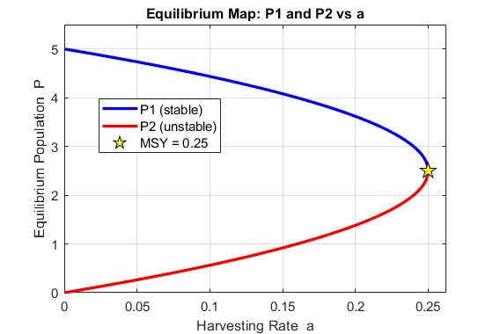
Figure 3.1 — Equilibrium Map (P1 and P2 vs a)
The equilibrium map shows both P1 and P2 plotted as continuous curves against the harvesting rate a ranging from 0 to the MSY. As a increases from 0, P1 decreases from N while P2 increases from 0. The two curves meet at the MSY point (a = 0.25, P = 2.5), forming a characteristic saddle-node bifurcation. Beyond this point both curves become undefined, indicating extinction.
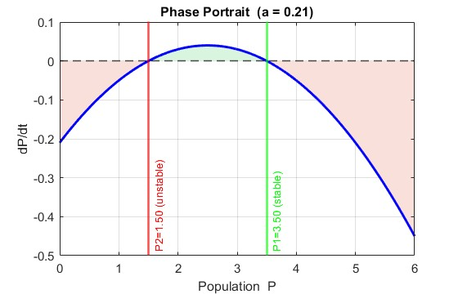
Figure 3.2 — Phase Portrait (dP/dt vs P)
The phase portrait plots dP/dt against P for the constant harvesting equation. The curve crosses the horizontal axis at P2 and P1. Between these two points the curve is positive meaning the population grows. Outside this interval the curve is negative meaning the population declines. The two zero crossings directly correspond to the unstable equilibrium P2 and the stable equilibrium P1.

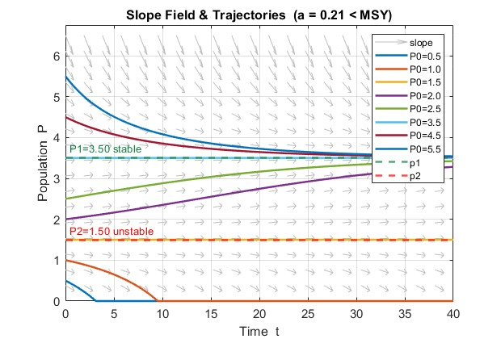

Figure 3.3 — Slope Field and Trajectories for a < MSY (a = 0.21)
The slope field shows horizontal arrows near P1 = 3.5 and diverging arrows near P2 = 1.5. Solution curves starting above P2 converge toward P1 over time confirming its stability. Solution curves starting below P2 decline toward zero confirming the danger threshold behavior of P2.

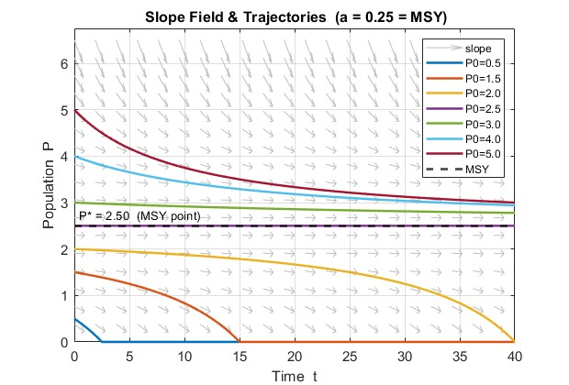
Figure 3.4 — Slope Field and Trajectories at a = MSY (a = 0.25)
At the MSY the two equilibria merge at P* = 2.5. Solution curves starting above this point slowly converge toward P* = 2.5 from above, while curves starting below it decline to extinction. The system is at its most delicate balance — any slight increase in harvesting beyond this point causes collapse.

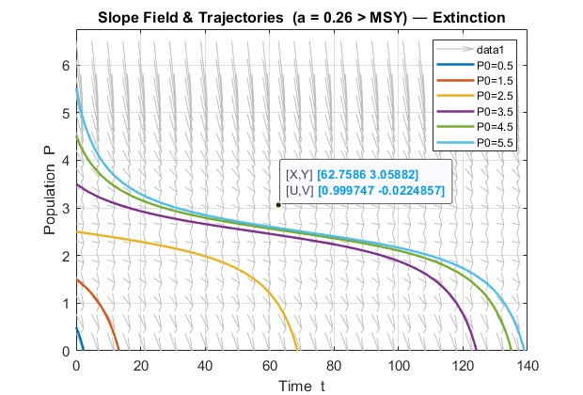

Figure 3.5 — Slope Field and Trajectories for a > MSY (a = 0.26)
When the harvesting rate exceeds the MSY no equilibrium exists. All solution curves regardless of initial condition decline monotonically to zero. This confirms that harvesting beyond the MSY inevitably leads to population extinction.

3.8 Discussion
The results of the constant harvesting model reveal several important findings.
First, the existence of two equilibrium points P1 and P2 creates a bi-stability structure in the system. The upper equilibrium P1 is where the fishery naturally settles when properly managed, representing a sustainable population level. The lower equilibrium P2 is not a safe target — it is an unstable threshold that the population must remain above to avoid collapse.
Second, the Maximum Sustainable Yield of kN/4 = 0.25 provides a hard mathematical limit for fishery management. Setting the harvesting rate at or below this value guarantees the existence of a stable equilibrium. Exceeding it — even slightly — eliminates all equilibria and guarantees extinction regardless of the current population size.
Third, the role of initial conditions is critical for populations near P2. A population slightly above P2 will recover to P1, while a population slightly below P2 will collapse to extinction. This sensitivity near the unstable equilibrium underscores the importance of monitoring actual fish population levels and not just harvesting rates.
Taken together these findings demonstrate that constant harvesting imposes a rigid structure on the population dynamics. While mathematically tractable and analytically solvable, constant harvesting does not reflect the seasonal reality of most fisheries, which motivates the study of periodic harvesting in Chapter 4.

Chapter 4: Model 2 — Logistic Growth with Periodic Harvesting
4.1 Model Formulation
In reality, fishing activity does not occur at a constant rate throughout the year. Fishing grounds are opened and closed according to seasons, weather conditions, and regulatory schedules. To model this more realistic scenario, the constant harvesting term a is replaced by a sinusoidal function that oscillates over time. The resulting periodic harvesting model is:
dP/dt = kP(1 - P/N) - a(1 + sin(bt))
where:
Parameter | Description | Unit
P | Size of the fish population at time t | number of fish
t | Time | years or seasons
k | Intrinsic growth rate | per unit time
N | Carrying capacity of the environment | number of fish
a | Harvesting amplitude — controls intensity of harvesting | fish per unit time
b | Angular frequency — controls how often harvesting cycles occur | radians per unit time
The term a(1 + sin(bt)) represents a harvesting rate that oscillates between 0 and 2a over time. When sin(bt) = 1 the harvesting is at its peak intensity of 2a. When sin(bt) = -1 the harvesting drops to zero, representing a closed fishing season. When sin(bt) = 0 the harvesting equals a, representing the average rate. This structure naturally captures the opening and closing of fishing seasons throughout the year.

4.2 Role of Parameter a
The parameter a in the periodic harvesting model controls the amplitude and average intensity of the harvesting function. Specifically it determines how much fish is removed on average per unit time and how large the seasonal swings in harvesting are.
When a is small the harvesting oscillations are mild and the population has sufficient time to recover between fishing seasons. The population fluctuates but remains at a healthy level above the danger threshold.
When a is increased toward the MSY value of kN/4 the oscillations become more severe. During peak harvesting seasons the removal rate reaches 2a which can temporarily drive the population below its safe threshold. Even if the population partially recovers during the closed season, repeated exposure to high peak harvesting rates causes a net downward trend in population size over time.
When a equals the MSY the average harvesting rate is already at the biological limit of the population. Since the peak harvesting rate reaches 2a = 2 x MSY during the sine peak, the population is repeatedly pushed far beyond what it can sustain, leading to rapid decline. This is why in the periodic model the effective safe harvesting limit is lower than in the constant model — the oscillations add an extra stress that the constant model does not capture.

4.3 Role of Parameter b
The parameter b controls the frequency of the harvesting cycle — that is, how many complete harvesting seasons occur per unit time. The period of one complete harvesting cycle is:
Period = 2pi / b
Specific values of b and their biological interpretation are:
Value of b | Period = 2pi/b | Biological Meaning
0.5 | 12.57 | One slow harvesting cycle every 12.57 time units — long recovery periods
1.0 | 6.28 | One harvesting cycle every 6.28 time units — standard seasonal fishing
2.0 | 3.14 | Two harvesting cycles per 3.14 time units — more frequent harvesting
4.0 | 1.57 | Four harvesting cycles per 1.57 time units — very frequent short seasons
When b is small the harvesting cycles are long and slow. The population experiences long periods of low harvesting during which it can recover substantially before the next peak. When b is large the harvesting cycles are short and rapid. The population is hit repeatedly with peak harvesting before it has time to recover, causing a stronger cumulative downward pressure on the population even if the average harvesting rate a remains the same.

4.4 Why No Analytic Solution Exists
The constant harvesting model dP/dt = kP(1 - P/N) - a is an autonomous ODE because the right-hand side depends only on P and not on time t. This allowed the equation to be solved analytically using separation of variables and partial fractions.
The periodic harvesting model dP/dt = kP(1 - P/N) - a(1 + sin(bt)) is a non-autonomous ODE because the sine term introduces an explicit dependence on time t. This has two important consequences.
First, separation of variables is no longer possible. When attempting to separate the equation:
dP / [kP(1 - P/N) - a(1 + sin(bt))] = dt
the left-hand side contains both P and t mixed together through the sine term, making clean separation impossible.
Second, the concept of fixed equilibrium points breaks down. In the autonomous case dP/dt = 0 gave fixed values P1 and P2 that did not change with time. In the non-autonomous case setting dP/dt = 0 gives:
kP(1 - P/N) = a(1 + sin(bt))
The right-hand side changes with every value of t, meaning the equilibrium position itself shifts continuously over time. There are no fixed steady states — only time-varying quasi-equilibria that oscillate with the harvesting cycle.
For these reasons no closed-form analytic solution exists for the periodic harvesting model and the solution must be obtained entirely through numerical methods.

4.5 Numerical Approach
Since the periodic harvesting model cannot be solved analytically, numerical integration is used to approximate the solution. The method used in this study is the fourth-order Runge-Kutta method (RK4), implemented through MATLAB's built-in ode45 solver.
The RK4 method works by advancing the solution from time t_n to t_(n+1) = t_n + h using four slope estimates:
k1 = f(t_n, P_n)
k2 = f(t_n + h/2, P_n + h/2 x k1)
k3 = f(t_n + h/2, P_n + h/2 x k2)
k4 = f(t_n + h, P_n + h x k3)
P_(n+1) = P_n + (h/6)(k1 + 2k2 + 2k3 + k4)
where h is the step size and f(t, P) = kP(1 - P/N) - a(1 + sin(bt)) is the right-hand side of the ODE.
MATLAB's ode45 uses an adaptive step size — it automatically makes h smaller when the solution is changing rapidly and larger when it is changing slowly. This ensures both accuracy and efficiency without requiring the user to manually choose a step size. A relative tolerance of 1e-8 and absolute tolerance of 1e-10 are used throughout this study to ensure high accuracy in all numerical solutions.

4.6 Results and Plots

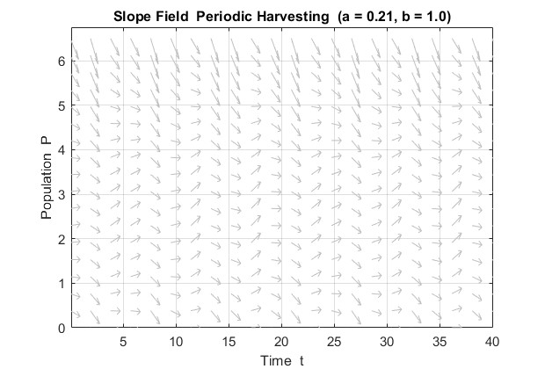
Figure 4.1 — Slope Field for Periodic Harvesting (a = a1 = 0.21)
Unlike the constant harvesting slope field which shows uniform horizontal arrows near the equilibrium, the periodic harvesting slope field shows arrows that vary in direction depending on both P and t. This time-dependent variation in the slope field is a direct visual consequence of the non-autonomous nature of the equation. The arrows oscillate in direction across time, reflecting the periodic rise and fall of the harvesting rate.
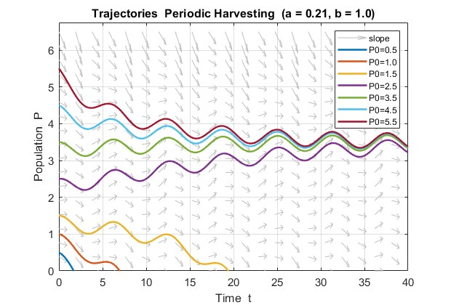
Figure 4.2 — Trajectories for Periodic Harvesting (a = a1 = 0.21)
For a = 0.21, which is below the MSY of 0.25, the population trajectories show a characteristic oscillating behavior. Instead of converging smoothly to a fixed equilibrium as in the constant harvesting model, the population rises and falls repeatedly in response to the sinusoidal harvesting cycle. Populations starting above the danger zone settle into a sustained oscillation around a mean value below N. Populations starting very low decline toward extinction during the peak harvesting phase before the closed season can allow recovery.

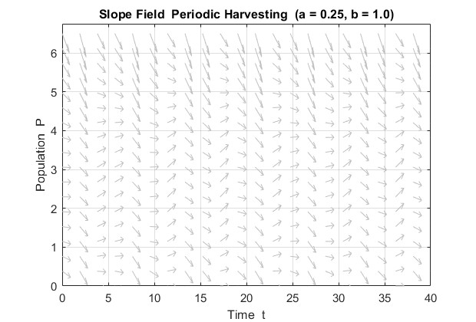

Figure 4.3 — Slope Field for Periodic Harvesting (a = a2 = 0.25)
At a = 0.25 the slope field shows more aggressively downward-pointing arrows compared to the a = 0.21 case. This reflects the fact that the peak harvesting rate now reaches 2 x 0.25 = 0.50, which is double the MSY. The slope field clearly shows that for most values of P the population is being driven downward during peak harvesting periods.

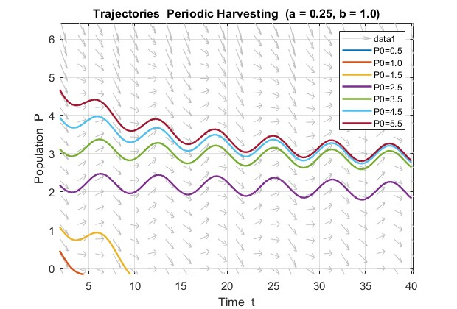

Figure 4.4 — Trajectories for Periodic Harvesting (a = a2 = 0.25)
At a = a2 = 0.25 the effect of the sine function becomes fully apparent. The population undergoes a rapid drop that is much more severe than in the a = 0.21 case. The oscillations are larger in amplitude and the mean population level declines noticeably over time. Trajectories that appeared sustainable at a = 0.21 now show a clear downward trend, demonstrating that the periodic harvesting model reaches its effective limit at a value lower than the theoretical MSY of the constant model.

4.7 Effect of Parameter b
To investigate how harvesting frequency affects population dynamics, the parameter b is varied while keeping all other parameters fixed at k = 0.20, N = 5, a = 0.21, and P0 = 4.0.
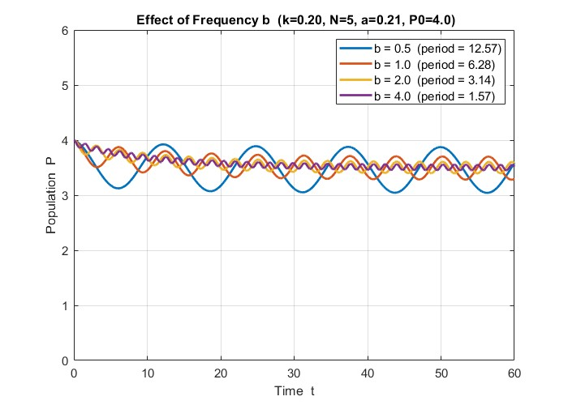

Figure 4.5 — Trajectories for Varying b (b = 0.5, 1, 2, 4)
The results show that increasing b leads to more frequent but shorter harvesting cycles. At b = 0.5 the population oscillates with a long slow wave — it rises substantially during the long closed season and drops during the long peak season, producing wide oscillations. At b = 1.0 the oscillations are moderate and represent the standard seasonal fishing scenario. At b = 2.0 the oscillations become more frequent and smaller in amplitude as the population no longer has enough time to fully recover or fully decline within each short cycle. At b = 4.0 the rapid oscillations average out and the population behavior begins to resemble a smoothly declining curve close to the constant harvesting case.
This result demonstrates an important finding: for the same average harvesting rate a, a lower frequency b is more damaging to the population because it allows extreme peaks in harvesting that the population cannot survive, whereas a higher frequency b spreads the harvesting more evenly and reduces the shock of each individual peak.

4.8 Discussion
The periodic harvesting model reveals several important findings that are not visible in the constant harvesting model.
First, the population under periodic harvesting never reaches a true steady state. Unlike the constant harvesting case where populations converge to the fixed stable equilibrium P1, the periodic model produces sustained oscillations that continue indefinitely. The population is always responding to the current phase of the harvesting cycle — growing during the closed season and declining during the open season.
Second, the effective safe harvesting limit in the periodic model is lower than the MSY derived for the constant model. Because the peak harvesting rate reaches 2a during each cycle, the population is periodically subjected to a harvesting intensity double the average rate. This means that setting a = MSY in the periodic model is already dangerous, since the peaks will repeatedly push the population into the extinction zone.
Third, the timing and frequency of harvesting matters significantly. A lower frequency b produces more extreme population swings and is more likely to push the population below its danger threshold during peak seasons. A higher frequency b smooths out the harvesting stress and is generally less damaging to the population for the same average rate a.
Fourth, the comparison between Figures 4.2 and 4.4 clearly shows that moving from a = 0.21 to a = 0.25 causes a qualitative change in population behavior — from sustained oscillation to progressive decline. This transition has direct implications for fishery management: even a small increase in the harvesting rate near the MSY boundary can shift the fishery from a sustainable oscillating regime to an unsustainable declining one.
These findings collectively suggest that periodic harvesting, while more realistic than constant harvesting, requires more conservative management targets to ensure long-term population survival. The analysis in Chapter 5 will directly compare both models and quantify the sensitivity of each to changes in the key parameters.

Chapter 5: Comparison and Sensitivity Analysis
5.1 Constant vs Periodic — Same Parameters
To directly compare the two harvesting models, both are simulated using identical parameter values: k = 0.20, N = 5, a = 0.21, b = 1.0, and P0 = 4.0. The only difference between the two simulations is the form of the harvesting term — constant a versus periodic a(1 + sin(bt)).

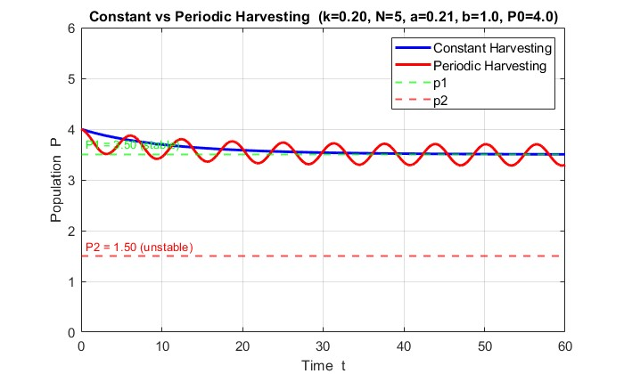
Figure 5.1 — Constant vs Periodic Harvesting (Same Parameters)
The side-by-side comparison reveals a fundamental difference in long-term population behavior between the two models. Under constant harvesting the population follows a smooth monotonic trajectory that converges to the stable equilibrium P1 = 3.5 and remains there indefinitely. The population settles into a fixed steady state with no further fluctuation.
Under periodic harvesting with the same average harvesting rate a = 0.21, the population never reaches a fixed steady state. Instead it oscillates continuously in response to the sinusoidal harvesting cycle, rising during low-harvest phases and declining during peak-harvest phases. The mean population level under periodic harvesting is lower than the stable equilibrium P1 of the constant model because the peak harvesting rate of 2a = 0.42 periodically removes more fish than the average rate suggests.
This comparison demonstrates that using the constant model to set harvesting policy and then implementing periodic harvesting in practice will result in a lower actual population than predicted. The constant model overestimates the population level that can be sustained under seasonal harvesting conditions.

5.2 Which Model is More Realistic
From a biological and management perspective, the periodic harvesting model is significantly more realistic than the constant harvesting model for the following reasons.
First, real fisheries do not operate year-round at a fixed harvesting rate. Commercial and subsistence fishing is governed by seasonal regulations, weather patterns, fish migration cycles, and market demand. Fishing grounds are opened during peak seasons and closed during off-seasons to allow population recovery. The sinusoidal function a(1 + sin(bt)) captures this opening and closing cycle naturally.
Second, the constant harvesting model assumes that exactly a units of fish are removed per unit time regardless of how many fish are actually present. In practice this is impossible — when fish populations are low, fishing effort must decrease simply because fewer fish are available to catch. The periodic model, while still a simplification, at least acknowledges that harvesting intensity varies over time.
Third, the equilibrium analysis of the constant model produces clean analytical results that are mathematically elegant but biologically idealized. Real fish populations do not sit at a fixed equilibrium — they fluctuate in response to environmental variability, predator cycles, and seasonal productivity changes. The oscillating trajectories produced by the periodic model are visually and conceptually closer to what is observed in real fishery data.
However the periodic model also has limitations. The assumption of a perfect sinusoidal harvesting pattern is still a simplification. Real harvesting patterns are irregular and influenced by economic, political, and ecological factors that a single sine function cannot fully represent. Despite this, the periodic model provides a substantially more realistic framework than constant harvesting for guiding fishery management decisions.

5.3 Effect of Growth Rate k
The intrinsic growth rate k represents how rapidly the fish population reproduces under ideal conditions. To isolate its effect, N = 5 and a = 0.21 are held fixed while k is varied across the values 0.10, 0.20, 0.30, and 0.40.
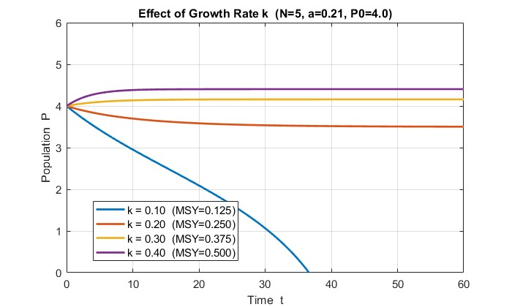
Figure 5.2 — Effect of Varying k on Population Trajectories
The results show that increasing k has two major effects. First, the stable equilibrium P1 increases as k increases because a higher growth rate means the population can sustain a larger stable size even under the same harvesting pressure. Second, the MSY increases proportionally with k since MSY = kN/4 — a faster-growing population can sustain a higher harvesting rate before collapsing.
The sensitivity of the equilibrium points to k is summarized below:
k | MSY = kN/4 | P1 (a=0.21) | P2 (a=0.21) | Status
0.10 | 0.125 | no real equilibria | no real equilibria | Extinction
0.20 | 0.250 | 3.5000 | 1.5000 | Two equilibria
0.30 | 0.375 | 4.0607 | 0.9393 | Two equilibria
0.40 | 0.500 | 4.2795 | 0.7205 | Two equilibria
A critical finding is that at k = 0.10 the MSY is only 0.125, which is already below the harvesting rate of a = 0.21. This means that a harvesting rate that is perfectly safe for a fast-growing population becomes catastrophic for a slow-growing one. This highlights the danger of applying a single harvesting rate across different fish species or populations with different growth characteristics.

5.4 Effect of Carrying Capacity N
The carrying capacity N represents the maximum population size the environment can support. To isolate its effect, k = 0.20 and a = 0.21 are held fixed while N is varied across the values 3, 5, 7, and 10.
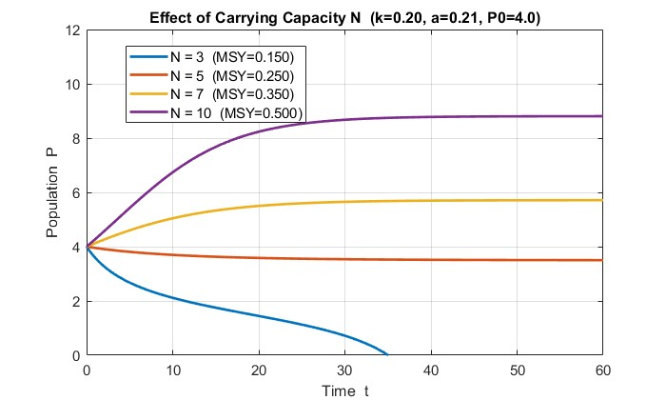
Figure 5.3 — Effect of Varying N on Population Trajectories
Increasing N raises the MSY and shifts both equilibrium points. A larger carrying capacity means the environment can support more fish, which in turn means more fish are available to absorb the same harvesting pressure. The population settles at a higher stable equilibrium and the danger threshold P2 moves lower, giving the fishery a wider safe operating window.
N | MSY = kN/4 | P1 (a=0.21) | P2 (a=0.21) | Status
3 | 0.150 | no real equilibria | no real equilibria | Extinction
5 | 0.250 | 3.5000 | 1.5000 | Two equilibria
7 | 0.350 | 5.8218 | 1.1782 | Two equilibria
10 | 0.500 | 9.0757 | 0.9243 | Two equilibria
At N = 3 the MSY is only 0.150, again below the harvesting rate of 0.21, leading to extinction. This illustrates that degrading the habitat — which reduces N through pollution, deforestation of riverbanks, or destruction of coral reefs — can push a previously sustainable fishery into collapse even without any change in the harvesting rate.

5.5 Effect of Harvesting Rate a
To examine how increasing the harvesting rate drives the system toward extinction, k = 0.20, N = 5, and P0 = 4.0 are held fixed while a is increased from 0 to 0.30 — spanning the safe zone, the MSY boundary, and the extinction zone.

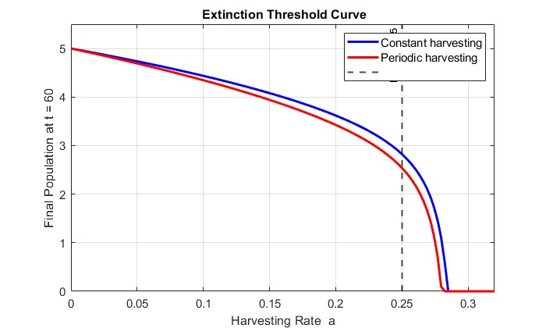
(need fix)
Figure 5.4 — Final Population vs Harvesting Rate a (Extinction Threshold Curve)
This figure plots the population at the end of the simulation (t = 60) against the harvesting rate a for both the constant and periodic models. For the constant model the final population remains near P1 for all a below the MSY of 0.25, then drops sharply to zero as a crosses 0.25. The transition is abrupt — a tiny increase in a beyond the MSY causes complete collapse.
For the periodic model the decline begins earlier — the final population starts dropping noticeably before a reaches the MSY because the peak harvesting rate 2a already exceeds the MSY when a = 0.125. The curve falls more gradually but reaches zero at a lower value than the constant model.
This figure is one of the most important results of the study. It visually demonstrates the extinction threshold and shows that the periodic model is more sensitive to harvesting pressure than the constant model, reinforcing the need for more conservative harvesting limits when seasonal fishing patterns are used.

5.6 Effect of Initial Condition P0
To demonstrate the role of initial population size, k = 0.20, N = 5, and a = 0.21 are held fixed while P0 is varied above and below the unstable equilibrium P2 = 1.5.

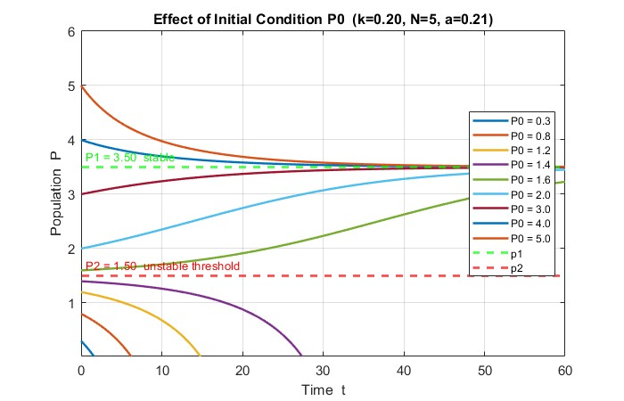
Figure 5.5 — Effect of Initial Condition P0 (Constant Harvesting)
The results confirm the theoretical prediction from the stability analysis in Chapter 3. Every trajectory starting above P2 = 1.5 — regardless of how far above — eventually converges to the stable equilibrium P1 = 3.5. Every trajectory starting below P2 = 1.5 declines monotonically to extinction. The boundary between survival and extinction is precisely P2.
This finding has a direct and critical management implication: the current population size matters as much as the harvesting rate. A fishery that has been overexploited and driven below P2 cannot recover on its own even if harvesting is immediately reduced to a = 0.21. Once the population crosses below the unstable equilibrium, only a complete cessation of harvesting — allowing the population to grow back above P2 — can prevent extinction.

5.7 Sensitivity Summary
The following table summarizes how each parameter affects the key model outputs — the stable equilibrium P1, the unstable equilibrium P2, and the Maximum Sustainable Yield.
Table 5.1 — Sensitivity Summary: Effect of Each Parameter on Model Outputs
Parameter | Increase Effect on MSY | Increase Effect on P1 | Increase Effect on P2 | Overall Risk if Decreased
k (growth rate) | MSY increases — kN/4 rises | P1 increases | P2 decreases | Very high — low k collapses MSY fast
N (carrying capacity) | MSY increases — kN/4 rises | P1 increases | P2 decreases | Very high — habitat loss is catastrophic
a (harvesting rate) | Not affected | P1 decreases | P2 increases | High — exceeding MSY causes extinction
b (frequency, periodic) | Not affected | No fixed P1 | No fixed P2 | Moderate — lower b causes larger swings
P0 (initial population) | Not affected | Not affected | Not affected | Critical — starting below P2 means extinction
Table 5.2 — Parameter Ranking by Impact on System Stability
Rank | Parameter | Reason
1 | a (harvesting rate) | Directly controls whether equilibria exist — exceeding MSY guarantees extinction
2 | k (growth rate) | Determines MSY — a slow-growing species collapses under harvesting that a fast-growing one survives
3 | N (carrying capacity) | Determines MSY — habitat degradation can push a sustainable fishery into collapse
4 | P0 (initial condition) | Does not affect equilibria but determines which basin of attraction the system enters
5 | b (frequency) | Only affects periodic model — influences oscillation amplitude but not mean stability
The sensitivity analysis confirms that the harvesting rate a and the biological parameters k and N are the three most critical factors governing the long-term survival of the fish population. Management strategies must account for all three simultaneously — setting a safe harvesting rate based on inaccurate estimates of k or N can lead to unintended collapse of the fishery.

Chapter 6: Conclusion
6.1 Summary of Findings
This study analyzed logistic population models with two forms of harvesting — constant and periodic — using both analytical and numerical methods. The key findings are summarized as follows.
For the constant harvesting model dP/dt = kP(1 - P/N) - a, the equilibrium analysis revealed the existence of two equilibrium points P1 and P2 derived from the quadratic formula:
P1 = (N + sqrt(N² - 4aN/k)) / 2 (stable)
P2 = (N - sqrt(N² - 4aN/k)) / 2 (unstable)
Using the parameters k = 0.20, N = 5, and a = 0.21, the equilibrium points were found to be P1 = 3.5 and P2 = 1.5. Stability analysis confirmed that P1 is a stable equilibrium toward which all populations starting above P2 converge, while P2 is an unstable threshold below which all populations decline to extinction. The Maximum Sustainable Yield was derived analytically as MSY = kN/4 = 0.25, representing the largest harvesting rate that permits the existence of real equilibrium points. When the harvesting rate exceeds the MSY the discriminant becomes negative, no real equilibria exist, and the population collapses to extinction regardless of its initial size.
For the periodic harvesting model dP/dt = kP(1 - P/N) - a(1 + sin(bt)), the non-autonomous nature of the equation made analytic solution impossible. Numerical integration using MATLAB's ode45 solver revealed that the population never reaches a fixed steady state but instead oscillates continuously in response to the sinusoidal harvesting cycle. At a = 0.21 the population sustains a stable oscillation around a mean value below P1. At a = 0.25 the oscillations become more severe and the mean population level declines noticeably over time. The sensitivity analysis demonstrated that increasing the harvesting frequency b reduces the amplitude of oscillations while decreasing b produces more extreme population swings that are more likely to push the population below its survival threshold.
The comparison between the two models showed that the constant harvesting model overestimates the sustainable population level because it does not account for the additional stress introduced by peak harvesting periods in the periodic model. The extinction threshold curve confirmed that the periodic model reaches zero population at a lower harvesting rate than the constant model, meaning that more conservative harvesting limits are required when seasonal fishing patterns are used.

6.2 Biological Implications
The mathematical results of this study carry direct and important implications for the management of real fish populations and fisheries.
First, the Maximum Sustainable Yield of MSY = kN/4 provides a hard upper limit for harvesting policy. Fishery managers must ensure that the total harvesting rate — accounting for commercial fishing, subsistence fishing, and bycatch — never exceeds this value. The results show that even a marginal exceedance of the MSY, such as increasing a from 0.25 to 0.26, is sufficient to eliminate all equilibria and drive the population to extinction. This finding underscores the importance of applying precautionary harvesting limits with a safety margin below the theoretical MSY.
Second, the unstable equilibrium P2 defines a critical minimum population threshold. Any fish population that falls below P2 — whether due to overharvesting, environmental catastrophe, disease, or habitat loss — will continue to decline and cannot recover on its own even if harvesting is immediately halted. This means that population monitoring is not optional — it is a biological necessity. Fishery managers must track actual population levels continuously and respond immediately when the population approaches P2.
Third, the sensitivity analysis revealed that the growth rate k and carrying capacity N are as important as the harvesting rate a in determining the sustainability of a fishery. A slow-growing species or a species living in a degraded habitat with low carrying capacity has a much lower MSY and is therefore far more vulnerable to the same harvesting pressure that a fast-growing species in a healthy habitat could sustain indefinitely. This means that harvesting limits must be species-specific and habitat-specific — a single universal harvesting policy cannot safely apply to all fisheries.
Fourth, the periodic harvesting results show that the timing and pattern of harvesting matter as much as the total amount harvested. Even if the average harvesting rate is below the MSY, the peak harvesting rate during the open season can temporarily exceed what the population can sustain, causing cumulative damage over multiple seasons. Fishery regulations that control only the total annual catch without regulating the timing and intensity of fishing within the season may be insufficient to prevent long-term population decline.

6.3 Comparison of Models
Both the constant and periodic harvesting models provide valuable but complementary insights into fish population dynamics. The constant harvesting model is analytically tractable and produces clean closed-form results for the equilibrium points and MSY. It is an excellent tool for understanding the fundamental structure of the harvesting problem — identifying the existence, location, and stability of equilibria, and establishing the theoretical maximum sustainable yield. For introductory analysis and policy benchmarking the constant model is indispensable.
However the periodic harvesting model is unambiguously more realistic as a representation of actual fishery operations. Real fishing activity is inherently seasonal — governed by weather, migration patterns, spawning seasons, and regulatory closures. The sinusoidal harvesting function captures this variability naturally and produces population trajectories that oscillate in a manner consistent with what is observed in real fishery data. The periodic model also reveals risks that the constant model completely conceals — specifically the danger posed by peak harvesting rates and the fact that the effective safe harvesting limit is lower than the theoretical MSY when seasonal patterns are present.
For practical fishery management the periodic model should be preferred as the primary planning tool, with the constant model used as a theoretical reference to establish upper bounds on sustainable harvesting. Together the two models provide a more complete picture of fish population dynamics than either could provide alone.

6.4 Limitations of the Study
While this study provides meaningful insights into harvested population dynamics, several important limitations must be acknowledged.
First, the model considers only a single isolated species with no interactions with other species. In reality fish populations exist within complex food webs involving predators, prey, and competitors. Ignoring these interactions may lead to overestimates of the carrying capacity and MSY since competition and predation reduce the effective resources available to the target species.
Second, the model is entirely deterministic — it assumes that all parameters k, N, and a are known constants that do not vary randomly over time. In reality all of these parameters are subject to environmental stochasticity. Growth rates fluctuate with temperature and food availability, carrying capacity varies with seasonal productivity, and actual harvesting rates vary with market demand, weather, and fishing effort. A stochastic model would produce a distribution of possible outcomes rather than a single deterministic trajectory and would likely reveal a higher risk of extinction than the deterministic model suggests.
Third, the model treats the population as spatially homogeneous — all fish are equally accessible to harvesting at all times. Real fish populations are spatially distributed across large areas with varying habitat quality, and fishing effort is concentrated in certain locations. Spatial heterogeneity can create refugia where fish are protected from harvesting, which stabilizes the population in ways the present model cannot capture.
Fourth, the model does not account for age or size structure within the population. In reality juvenile fish do not contribute to reproduction and are often more vulnerable to environmental stress than adults. A structured population model would provide a more accurate picture of how harvesting of different age classes affects long-term population viability.
Fifth, the sinusoidal harvesting function used in the periodic model is a mathematical idealization. Real harvesting patterns are irregular and do not follow a perfect sine wave. More realistic harvesting functions would require empirical data from actual fisheries to parameterize correctly.

6.5 Recommendations
Based on the findings of this study, the following recommendations are made for the management of harvested fish populations.
First, harvesting rates should always be set below the Maximum Sustainable Yield with an explicit safety margin. Given the sensitivity of the system near the MSY boundary — where a tiny increase in a causes complete collapse — a recommended practical limit is no more than 80 percent of the theoretical MSY. For the parameters of this study this corresponds to a maximum harvesting rate of 0.80 x 0.25 = 0.20.
Second, fishery managers should implement periodic harvesting with regulated seasonal closures rather than year-round constant harvesting. The periodic model shows that allowing the population to recover during closed seasons reduces the cumulative impact of peak harvesting and helps maintain the population above the danger threshold P2. Seasonal closures should be timed to coincide with spawning periods to maximize population recovery.
Third, continuous monitoring of actual fish population levels is essential. Since the unstable equilibrium P2 defines a critical threshold below which recovery is impossible, early warning systems should be established to trigger immediate management intervention — including emergency closures — when population estimates approach P2.
Fourth, harvesting limits must be regularly updated to reflect changes in the biological parameters of the population. If environmental degradation reduces the carrying capacity N or if disease reduces the growth rate k, the MSY will decrease accordingly and existing harvesting limits will become unsustainable. Regular stock assessments should be conducted to re-estimate k and N and adjust harvesting quotas accordingly.
Fifth, a precautionary approach should be applied especially for slow-growing species with low k values. The sensitivity analysis showed that the MSY scales directly with k — a species with half the growth rate has half the MSY. Harvesting limits that are safe for fast-growing species can be catastrophic for slow-growing ones and species-specific limits must always be used.

6.6 Future Work
This study opens several directions for future research that would extend and improve the models presented here.
First, a two-species model incorporating predator-prey dynamics alongside harvesting would provide a more realistic representation of the ecological system. The interaction between a harvested prey species and its predator introduces additional equilibria and stability conditions that could significantly alter the safe harvesting limits derived from the single-species model.
Second, the introduction of stochastic elements into the model would make it more applicable to real fishery management. Replacing the constant parameters k, N, and a with random variables drawn from appropriate distributions would allow the model to produce probability distributions for population outcomes and extinction risk rather than single deterministic trajectories. This would provide a more honest assessment of the uncertainty inherent in fishery management decisions.
Third, fitting the model parameters k and N to real fish population data using nonlinear least squares methods such as MATLAB's lsqcurvefit function would allow the model to make quantitative predictions for specific real-world fisheries. Comparison of model predictions with observed population trends would also allow validation of the logistic harvesting framework against empirical evidence.
Fourth, optimal control theory could be applied to find the harvesting strategy that maximizes total yield over a fixed time horizon subject to the constraint that the population must remain above a minimum viable level. This would move beyond the simple MSY concept and provide a dynamic harvesting schedule that adapts to the current state of the population rather than applying a fixed rate.
Fifth, a spatially explicit model incorporating fish movement between patches of different habitat quality and harvesting pressure would allow investigation of the role of marine protected areas — regions closed permanently to fishing — in stabilizing harvested populations. This has direct policy relevance for the design of marine conservation zones.

That is the complete Chapter 6 in plain copy pasteable text. You now have all six chapters complete. Let me know if you need any chapter revised or the final reference list written out.

